STUDENT LESSON

AB25 – Order of Algorithms

Student lesson

AB25 – Order of Algorithms

INTRODUCTION: Two critical criteria used for selecting a data structure and algorithm are the amount of memory required and the speed of execution. The analysis of the speed of an algorithm leads to a summary statement called the order of an algorithm.

The key topics for this lesson are:

A. Order of Algorithms
B. Constant Algorithms, O(1)
C. log₂N Algorithms, O(log₂N)
D. Linear Algorithms, O(N)
E. N * log₂N Algorithms, O(N * log₂N)
F. Quadratic Algorithms, (N2)
G. Other Orders
H. Comparison of Orders of Algorithms

VOCABULARY: BIG O NOTATION CONSTANT
CUBIC LINEAR
LOG2 N N LOG2 N
ORDER OF ALGORITHM QUADRATIC

DISCUSSION: A. Order of Algorithms

1. The order of an algorithm is based on the number of steps that it takes to complete a task. Time is not a valid measuring stick because computers have different processing speeds. We want a method of comparing algorithms that is independent of the computing environment and the speed of the microprocessor.

2. Most algorithms solve problems involving an amount of data, N. The order of algorithms will be expressed as a function of N, the size of the data set.

3. The following chart summarizes the numerical relationships of common functions of N.

A  N | B  O(log₂N) | C  O(N) | D  O(N* log₂N) | E  O(N2)
1 | 0 | 1 | 0 | 1
2 | 1 | 2 | 2 | 4
4 | 2 | 4 | 8 | 16
8 | 3 | 8 | 24 | 64
16 | 4 | 16 | 64 | 256
32 | 5 | 32 | 160 | 1024
64 | 6 | 64 | 384 | 4096
128 | 7 | 128 | 896 | 16384
256 | 8 | 256 | 2048 | 65536
512 | 9 | 512 | 4608 | 262144
1024 | 10 | 1024 | 10240 | 1048576

a. The first column, N, is the number of items in a data set.

b. The other four columns are mathematical functions based on the size of N. In computer science, we write this with a capital O (order) instead of the traditional F (function) of mathematics. This type of notation is the order of an algorithm, or Big O notation.

c. The graph below, Order of Algorithms, gives a clearer sense of the relationships among the columns of numbers. Since the vertical axis represents the theoretical number of steps required by an algorithm to sort a list of N items, lines B and C represent more efficient algorithms than D and E. Today’s data sets can grow to enormous sizes, so algorithm designers are always searching for ways to reduce the number of steps, even on the fastest supercomputers.

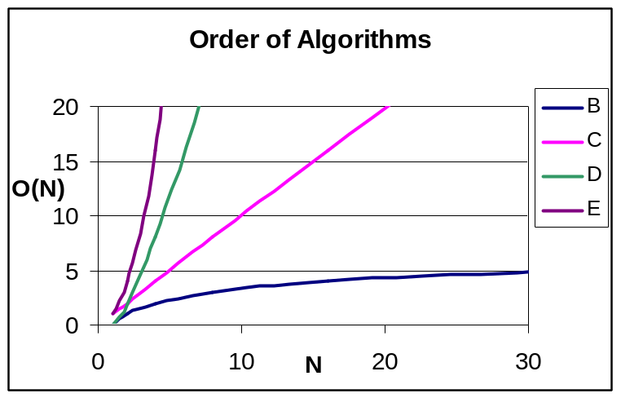

d. You have already seen column E in an experimental sense when you counted the number of steps in the quadratic sorting algorithms. The relationship between columns A and E is quadratic - as the value of N increases, the other column increases as a function of N2. The graph of column E is a portion of a parabola.

B. Constant Algorithms, O(1)

1. This relationship was not included in the Order of Algorithms graph. Here, the size of the data set does not affect the number of steps this type of algorithm takes. For example:

public int howBig(ArrayList <Integer> list){
return list.size();
}

2. The number of data items in the array could vary from 0…4000, but this does not affect the howBig algorithm. It will take one step regardless of how big the data set is.

3. A constant time algorithm could have more than just one step, as long as the number of steps is independent of the size (N) of the data set.

C. Log₂N Algorithms, O(log₂N)

1. A logarithm is the exponent to which a base number must be raised to equal a given number.

2. A log₂N algorithm, seen in line B on the Order of Algorithms graph, is one where the number of steps increases as a function of log₂N. If the number of data was 1024, the number of steps equals log₂1024, or 10 steps since 2¹⁰ = 1024.

3. Algorithms in this category involve splitting the data set in half repeatedly. Several examples will be encountered later in the course.

4. Algorithms that fit in this category are classed as O(log N), regardless of the numerical base used in the analysis.

D. Linear Algorithms, O(N)

1. This is an algorithm where the number of steps is directly proportional to the size of the data set, seen in line C on the Order of Algorithms graph. As N increases, the number of steps also increases.

public long sumData(ArrayList <Integer> list){
long total = 0;

Iterator <Integer> itr = list.iterator();
while(itr.hasNext()){
total += itr.next();
}

return total;
}

2. In the above example, as the size of the array increases, the number of steps increases at the same rate.

3. A non-recursive linear algorithm, O(N), always has a loop involved.

4. Recursive algorithms, in which the looping concept is developed through recursive calls, are usually linear. For example, the recursive factorial function is a linear function.

public long fact (int n) {
// precondition: n > 0

if (1 == n)
return 1;
else
return n * fact(n - 1);
}

The number of calls of fact will be n. Inside of the function is one basic step, an if/else. So we are executing one statement n times.

E. N * log₂N Algorithms, O(N * log₂N)

1. Algorithms of this type, seen in line D on the Order of Algorithms graph, have a log 2N procedure that must be applied N times.

2. The recursive MergeSort is a O(N * log₂N) algorithm.

3. As the graph shows, these algorithms are markedly more efficient than our next category, quadratics.

F. Quadratic Algorithms, (N2)

1. This is an algorithm, seen in line E on the Order of Algorithms graph, in which the number of steps required to solve a problem increases as a function of N2. For example, here is bubbleSort.

void bubbleSort(ArrayList <Comparable> list){
for (int outer = 0; outer < list.length - 1; outer++){
for (int inner = 0; inner < list.size()-outer-1; inner++){
if (list.get(inner).compareTo(list.get(inner + 1) > 0){
//swap list[inner] & list[inner+1]
Comparable temp = list.get(inner);
list.set(inner, list.get(inner + 1));
list.set(inner + 1, temp);
}
}
}

2. The if statement is buried inside nested loops, each of which is tied to the size of the data set, N. The if statement is going to be executed approximately N times for each of N items, or N2 times in all.

3. The efficiency of this bubble sort was slightly improved by having the inner loop decrease, but we still categorize this as a quadratic algorithm.

4. For example, the number of times the inner loop happens varies from 1 to (N-1). On average, the inner loop occurs (N/2) times.

5. The outer loop happens (N-1) times, or rounded off N times.

6. The number of times the if statement is executed is equal to this expression:

# if statements = (Outer loop) * (Inner loop)
# if statements = (N) * ()
# if statements =

7. The coefficient becomes insignificant for large values of N, so we have an algorithm that is quadratic in nature.

- When determining the order of an algorithm, we are only concerned with its category, not a detailed analysis of the number of steps.

G. Other Orders

1. A cubic algorithm is one where the number of steps increases as a cube of N, or N3.

2. An exponential algorithm is one where the number of steps increases as the power of a base, like 2N.

3. Both of these categories are astronomical in the number of steps required. Such algorithms are avoided when possible, and for large values of N can run slowly on even the fastest computers.

H. Comparison of Orders of Algorithms

- We obviously want to use the most efficient algorithm in our programs. Whenever possible, choose an algorithm that requires the fewest number of steps to process data.

SUMMARY/ REVIEW: | When designing solutions to programming problems, we are often concerned about finding the most efficient solutions regarding time and space. We will consider memory requirements at a later time. Speed issues are based on the number of steps required by algorithms.

ASSIGNMENT: Worksheet AB25.1, Order of Algorithms
Transparency AB25.1, Order vs. Efficiency

